COGNIZANT DIGITAL NURTURE 5.0 – DEEP SKILLING PHASE
WEEK 1 : Data Pattern and Algorithms – Mandatory Exercises
Submitted By
Name: Nishant Kumar
Superset ID: 7985565
Email: nishantkumar6205003458@gmail.com
University: C. V. Raman Global University, Odisha

Exercise 1: Implementing the Singleton Pattern
Aim
To implement the Singleton Design Pattern and ensure that only one instance of the Logger class is created throughout the application lifecycle.

Project Structure
SingletonPatternExample
├── Logger.java
└── SingletonTest.java

Logger.java
public class Logger {

private static Logger instance;

private Logger() {
System.out.println("Logger Instance Created");
}

public static Logger getInstance() {

if(instance == null) {
instance = new Logger();
}

return instance;
}

public void log(String message) {
System.out.println("LOG: " + message);
}
}

SingletonTest.java
public class SingletonTest {

public static void main(String[] args) {

Logger logger1 = Logger.getInstance();
Logger logger2 = Logger.getInstance();

logger1.log("Application Started");
logger2.log("User Logged In");

System.out.println("Logger1 HashCode : " + logger1.hashCode());
System.out.println("Logger2 HashCode : " + logger2.hashCode());

if(logger1 == logger2) {
System.out.println("Only One Instance Exists");
}
else {
System.out.println("Multiple Instances Exist");
}
}
}

Compilation and Execution
Compile:
javac *.java
Run:
java SingletonTest

Output
Logger Instance Created
LOG: Application Started
LOG: User Logged In
Logger1 HashCode : 980546781
Logger2 HashCode : 980546781
Only One Instance Exists

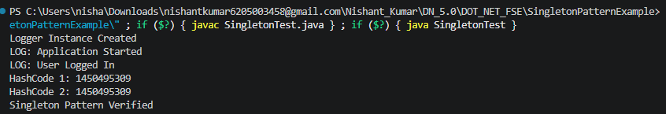

Exercise 2: Implementing the Factory Method Pattern
Aim
To implement the Factory Method Design Pattern for creating different types of documents such as Word, PDF, and Excel.

Project Structure
FactoryMethodPatternExample
├── Document.java
├── WordDocument.java
├── PdfDocument.java
├── ExcelDocument.java
├── DocumentFactory.java
├── WordFactory.java
├── PdfFactory.java
├── ExcelFactory.java
└── FactoryMethodTest.java

Document.java
public interface Document {
void open();
}

WordDocument.java
public class WordDocument implements Document {

@Override
public void open() {
System.out.println("Opening Word Document");
}
}

PdfDocument.java
public class PdfDocument implements Document {

@Override
public void open() {
System.out.println("Opening PDF Document");
}
}

ExcelDocument.java
public class ExcelDocument implements Document {

@Override
public void open() {
System.out.println("Opening Excel Document");
}
}

DocumentFactory.java
public abstract class DocumentFactory {

public abstract Document createDocument();
}

WordFactory.java
public class WordFactory extends DocumentFactory {

@Override
public Document createDocument() {
return new WordDocument();
}
}

PdfFactory.java
public class PdfFactory extends DocumentFactory {

@Override
public Document createDocument() {
return new PdfDocument();
}
}

ExcelFactory.java
public class ExcelFactory extends DocumentFactory {

@Override
public Document createDocument() {
return new ExcelDocument();
}
}

FactoryMethodTest.java
public class FactoryMethodTest {

public static void main(String[] args) {

DocumentFactory wordFactory = new WordFactory();
Document wordDocument = wordFactory.createDocument();
wordDocument.open();

DocumentFactory pdfFactory = new PdfFactory();
Document pdfDocument = pdfFactory.createDocument();
pdfDocument.open();

DocumentFactory excelFactory = new ExcelFactory();
Document excelDocument = excelFactory.createDocument();
excelDocument.open();
}
}

Output:-
